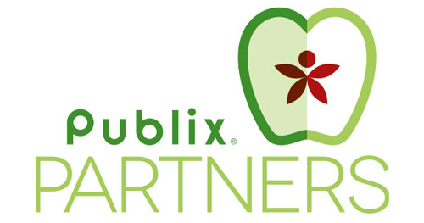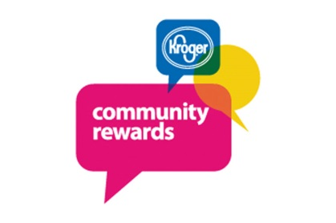

**Do you shop at Kroger or Publix?**

**They will donate a portion of your purchase to the school.**

It is easy, here is how to get started:

**Register your Kroger Plus Card**

* Obtain a card while checking out at Kroger
* Register your card online at krogercommunityrewards.com.
* Click on Sign-In if already a member. If new, click on Create an Account and complete the required personal fields.
* Kroger will send a confirmation email to you. Click on the link within the body of the email.
* Sign-In to continue to the next step.
* Click on Edit Kroger Community Rewards information and input or confirm your information.
* Enter the following NPO number: **67235** or search for Sedalia Park. Confirm you selection.
* ***You must swipe your registered Kroger Plus card or use the phone number related to your registered card when checking out in order for your purchase to count.***
* ***You must renew your subscription to Sedalia Park at the beginning of every school year.***

**Get a Publix Partner Card**

* Grab a Publix Partner Card from the front office and attach it to your key ring.
* At the beginning of your check out present your card to the cashier. No credit is given if cards are presented after the cashier totals the order.

